**School Yard, High Street, Harborne**

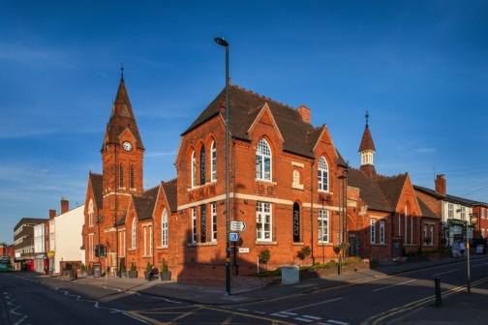

MK2 advised on an off market acquisition of the School Yard, High Street, Harborne on behalf of Avignon Capital Limited.

This recently developed prime leisure scheme is located in the heart of Harborne and let on long leases to Prezzo, Urban Coffee, Boston Tea Party and Harborne Food School with an initial rent of £184,000.

The purchase price was £2,550,000 reflecting a net initial yield of 6.83%.

PLEASE CAN YOU EMAIL ME: [JULES4@LIVE.CO.UK](mailto:JULES4@LIVE.CO.UK) WITH AMENDS OR CONFIRMATION THAT THIS CAN GO ON THE WEBSITE AND I WILL DO AT HOME. THANKS